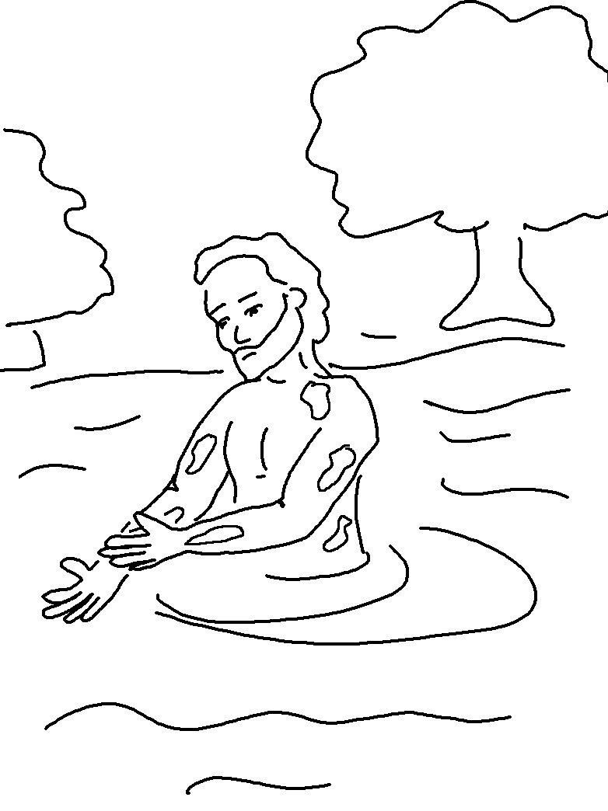

"You are my _ _ _ _ _ _ _ _ _," declares the Lord, "and my servant whom I have chosen." Isaiah 43:10_{NLT}

